**Using AWS code build pipeline build the docker image and push the images to ECR and pull the images to ECS Fargate**.

**To create the codebuild project**

1. Sign in to the AWS Management Console and open the AWS CodeBuild console at <https://console.aws.amazon.com/codesuite/codebuild/home>.
2. choose **Create build project**. Otherwise, on the navigation pane, expand **Build**, choose **Build projects**, and then choose **Create build project**.
3. On the **Create build project** page, in **Project configuration**, for **Project name**, enter a name for this build project (in this example, codebuild-demo-project). Build project names must be unique across each AWS account. If you use a different name, be sure to use it throughout this tutorial.

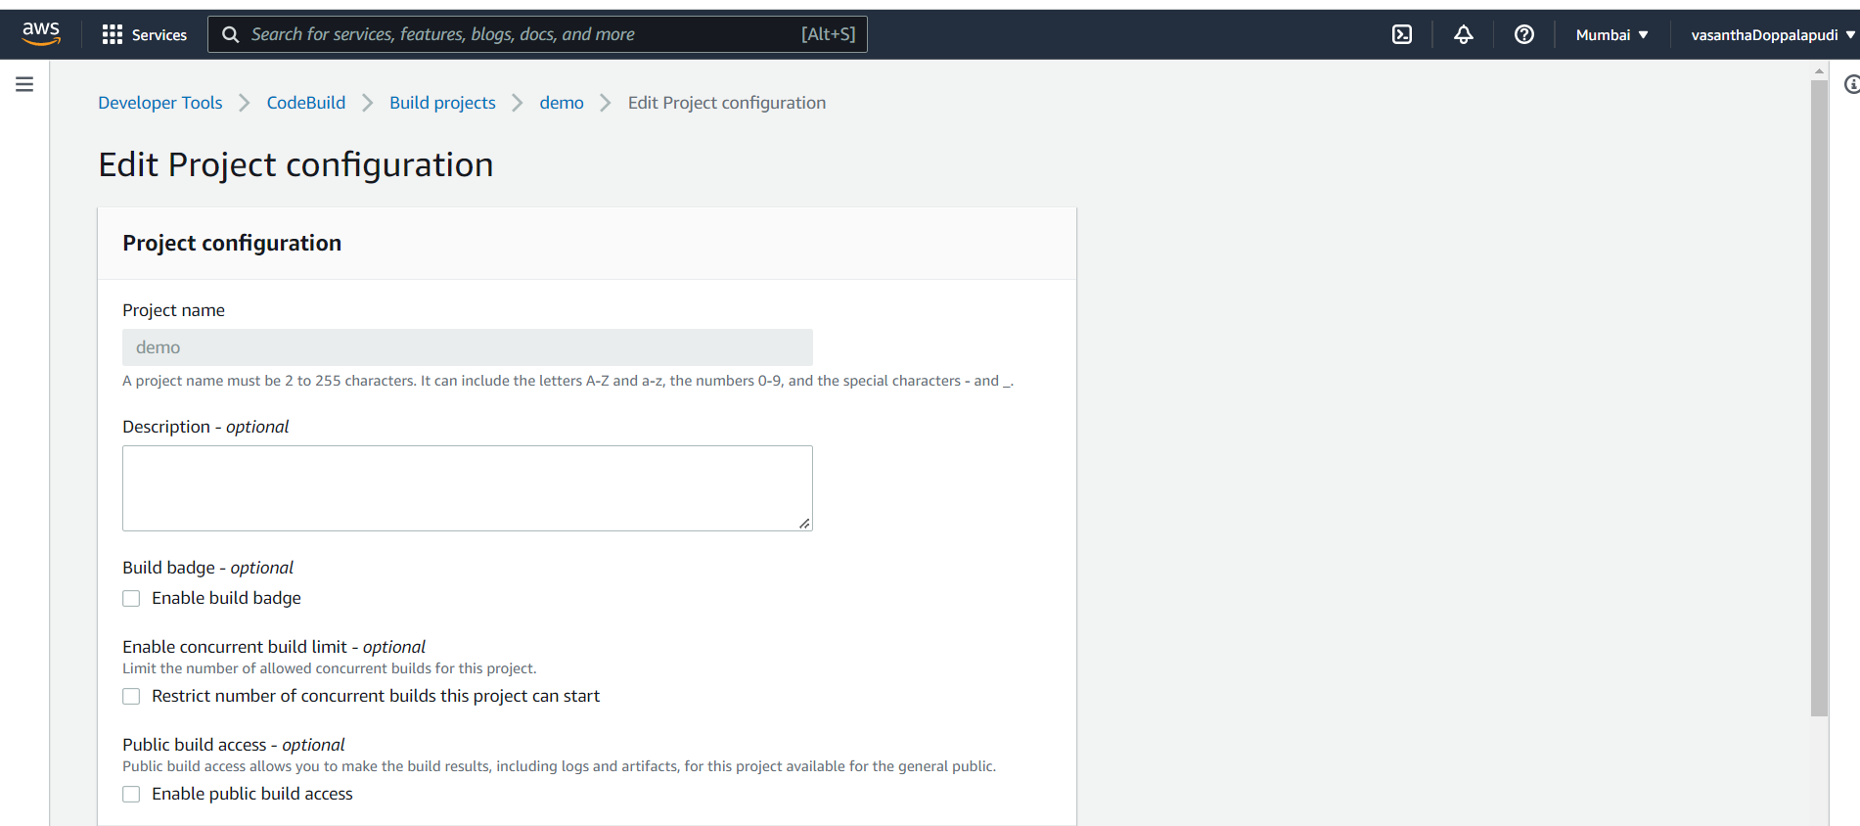

1. In **Source**, for **Source provider**, choose **GitHub**

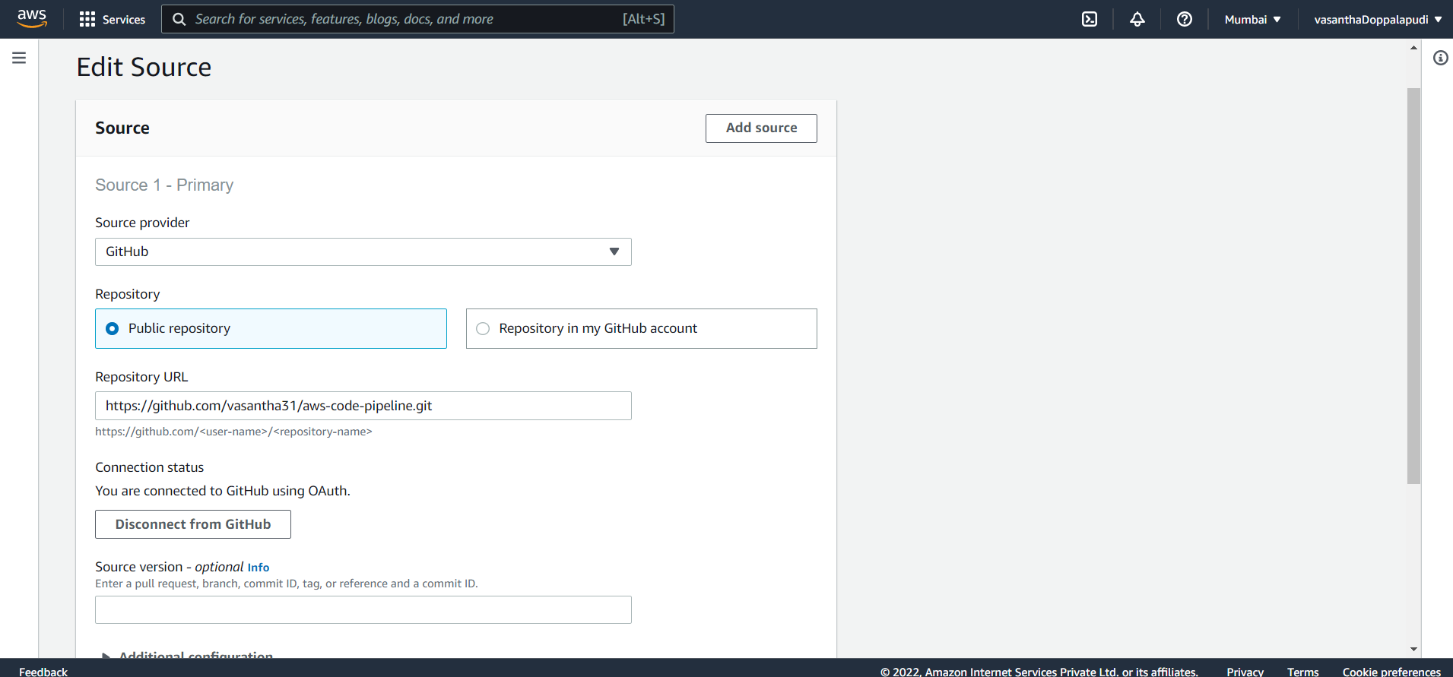

1. For **Operating system**, choose **Amazon Linux 2**.
2. For **Runtime(s)**, choose **Standard**.
3. For **Image**, choose **aws/codebuild/amazonlinux2-x86_64-standard:3.0**.
4. In **Service role**, leave **New service role** selected, and leave **Role name** unchanged.

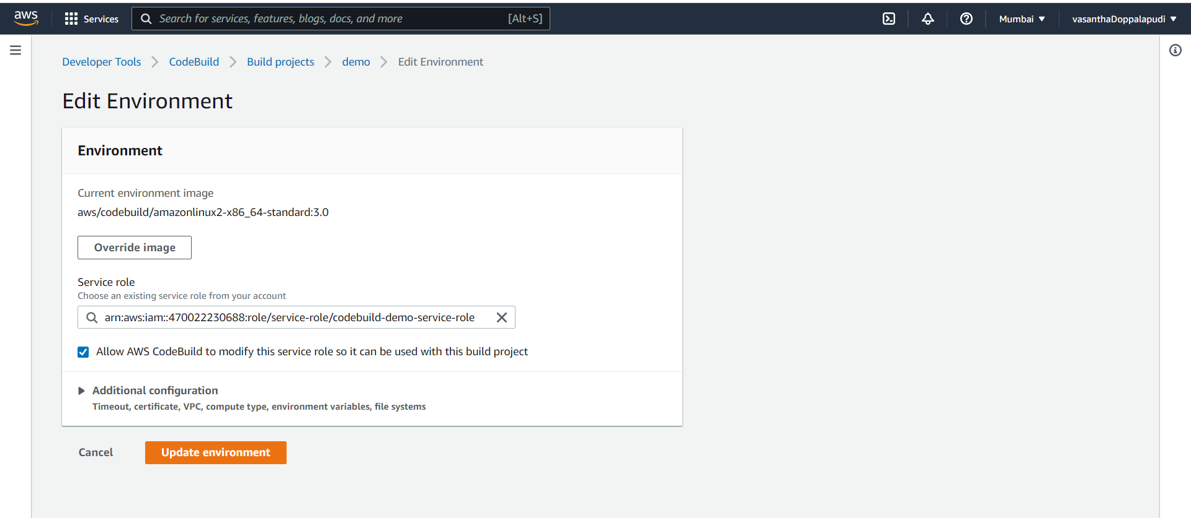

1. For **Buildspec**, leave **Use a buildspec file** selected.
2. In **Artifacts**, for **Type**, choose **Amazon S3**.
3. For **Bucket name**, choose **codebuild-*region-ID*-*account-ID*-output-bucket**.
4. Leave **Name** and **Path** blank.

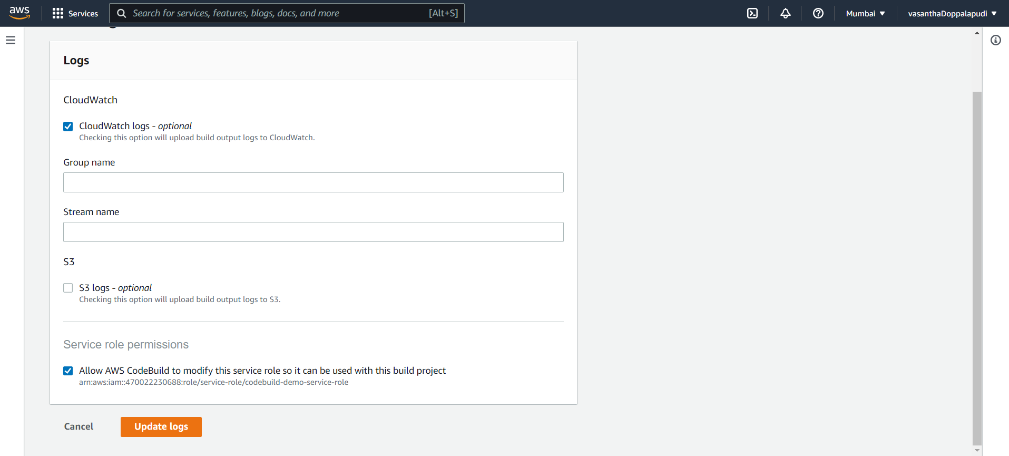

Choose **Create build project**.

**docker image and push the images to ECR**

* + Create an ecr repository
  + 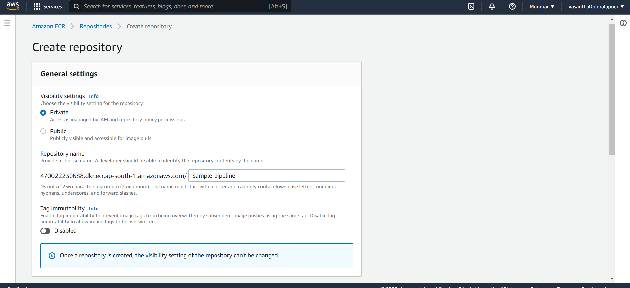
  + ECR repository created
  + 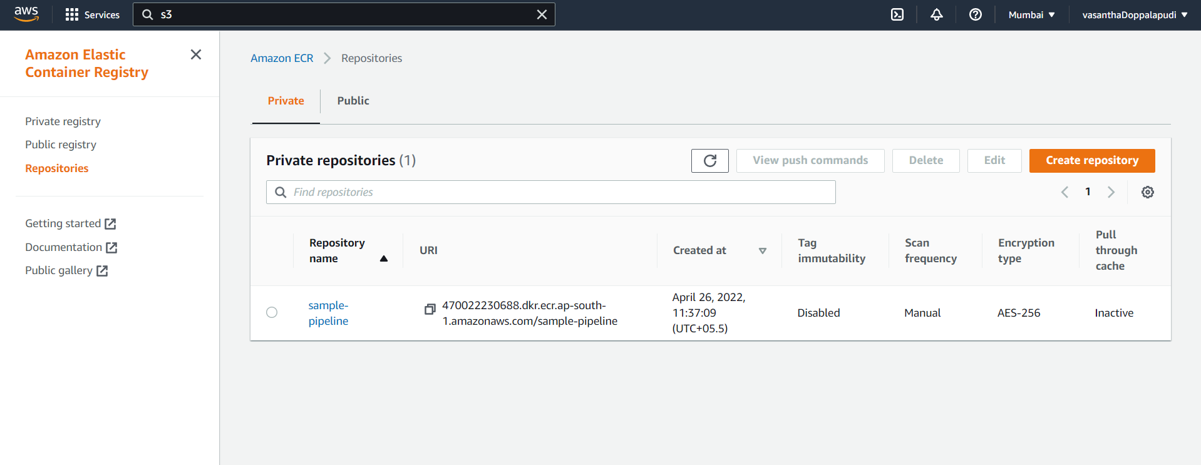
  + Goto IAM-> Roles and give full access permission.
  + 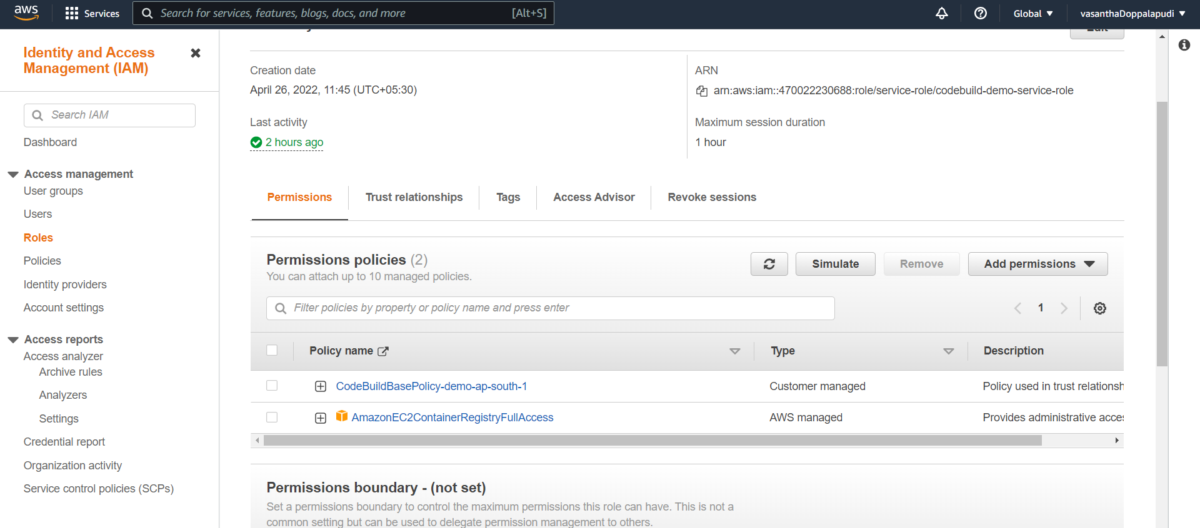
  + Go to codebuild and click on start build
  + 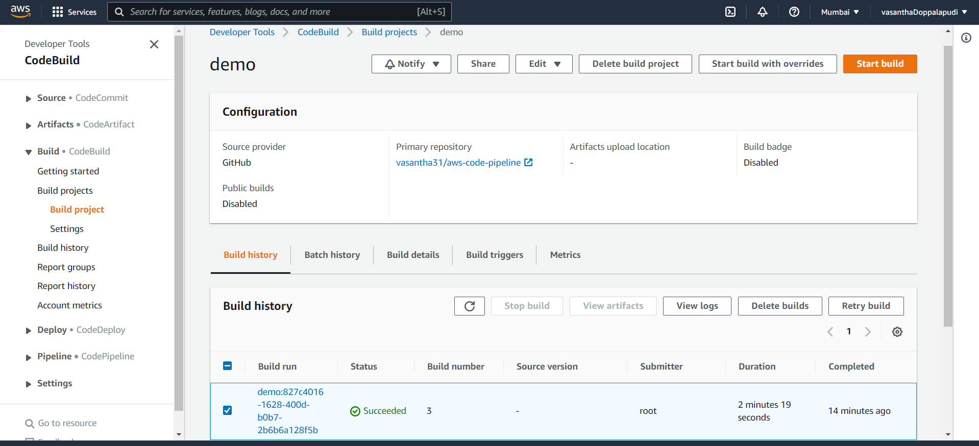
  + The build is success
  + 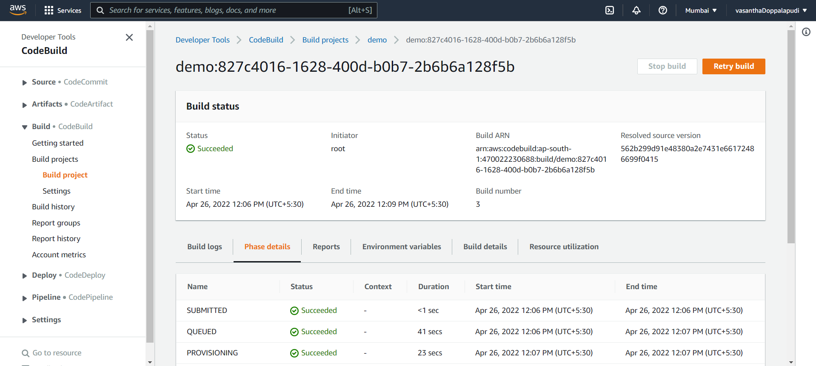
  + Docker image is pushed to the ECR
  + 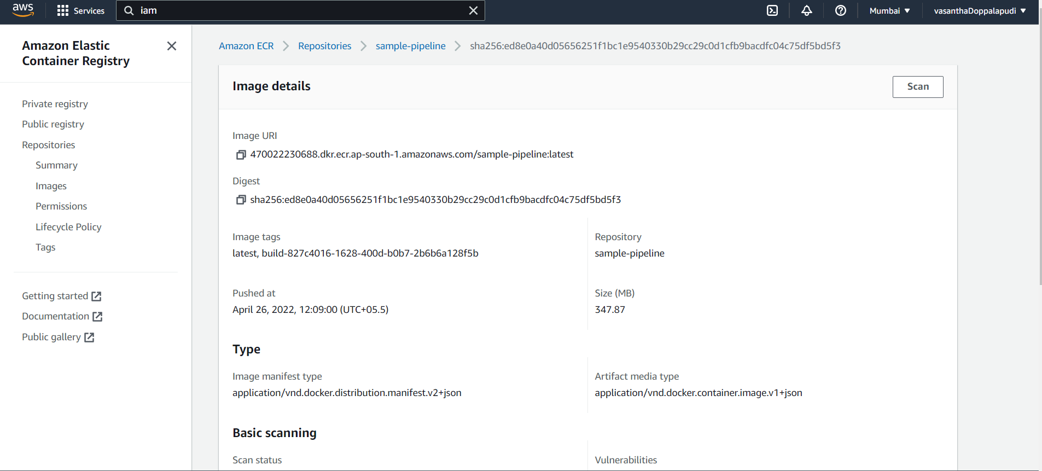

**pull the images to ECS Fargate**.

* + Go to IAM-> roles-> give full access
  + 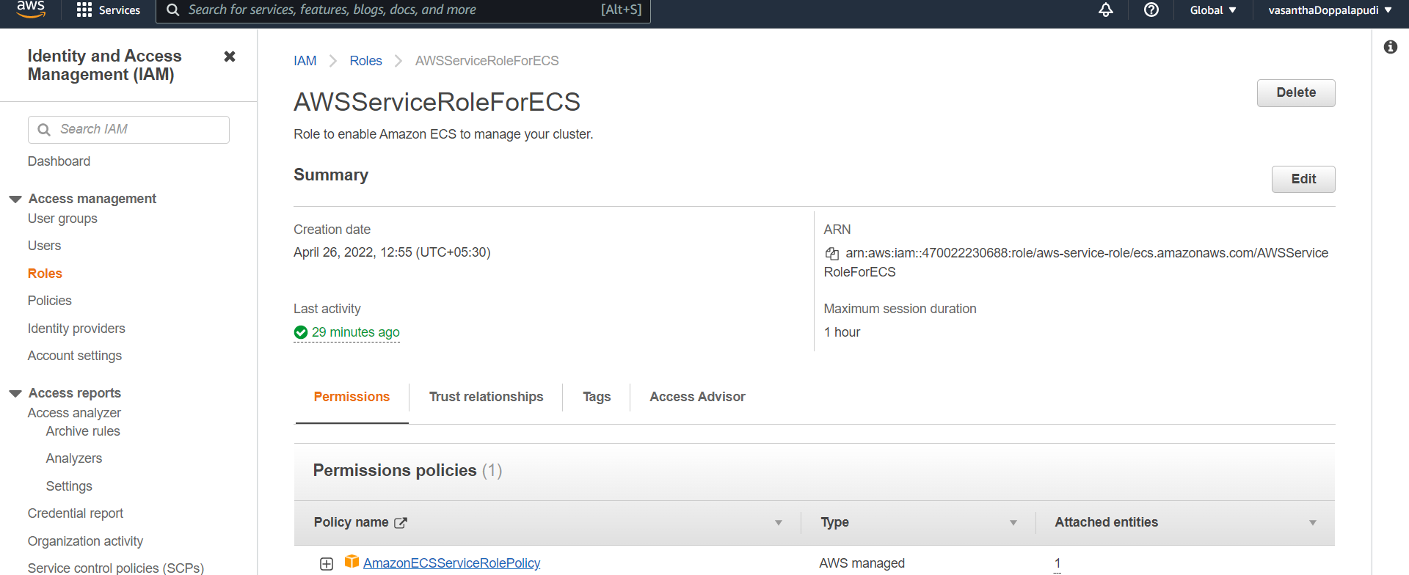
  + Goto ECS
  + Create a task definition
  + Select fargate
  + 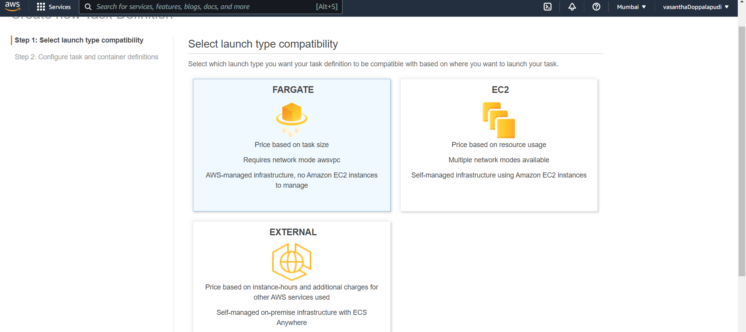
  + 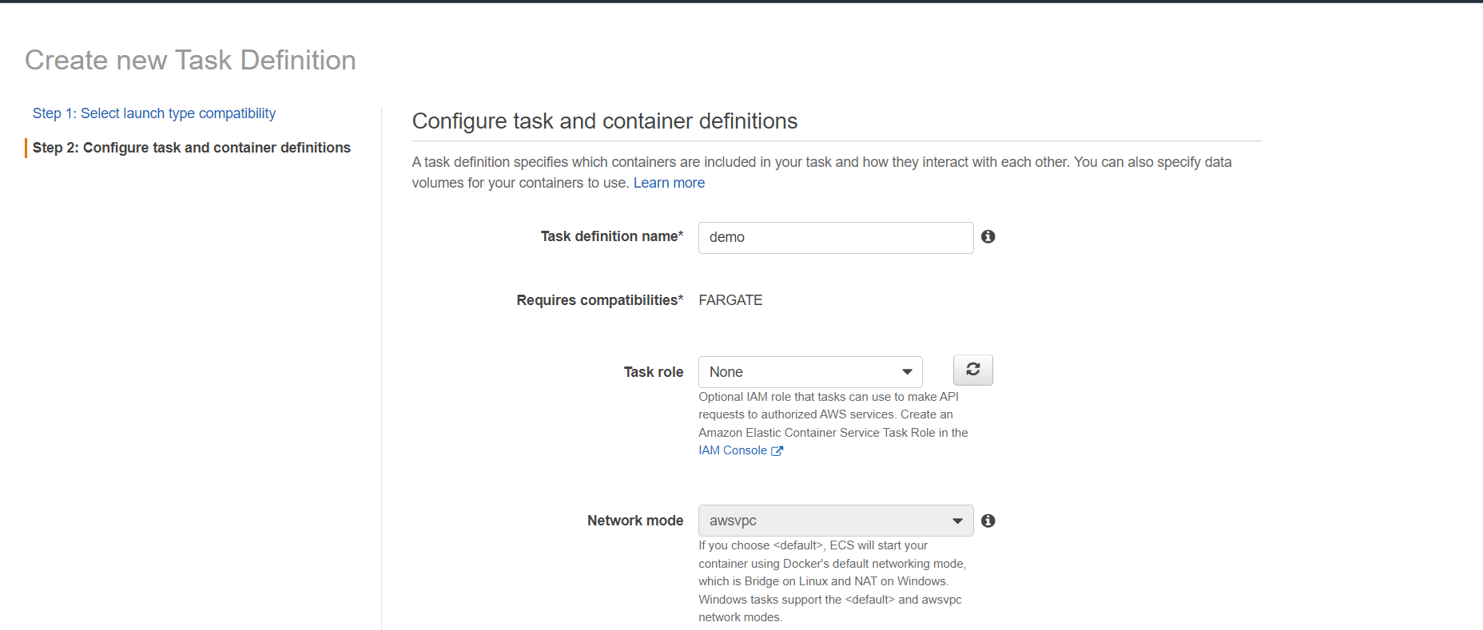
  + Add the container details
  + 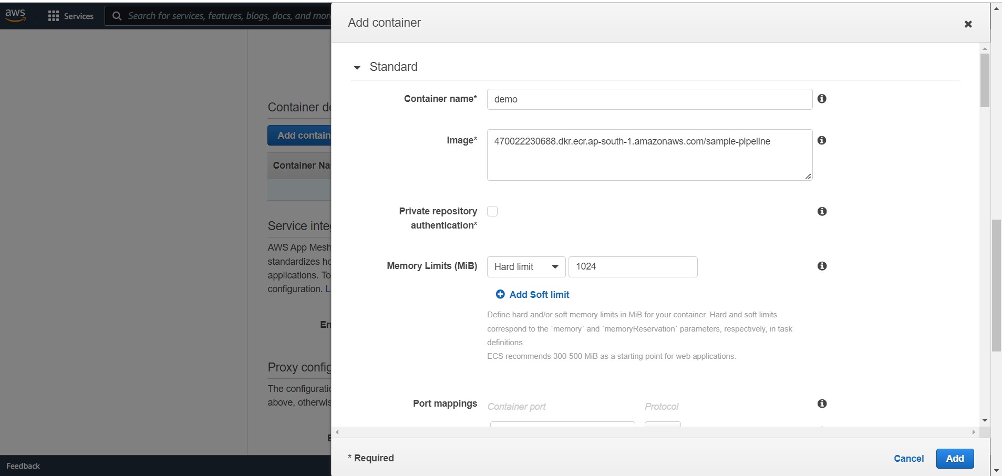
  + 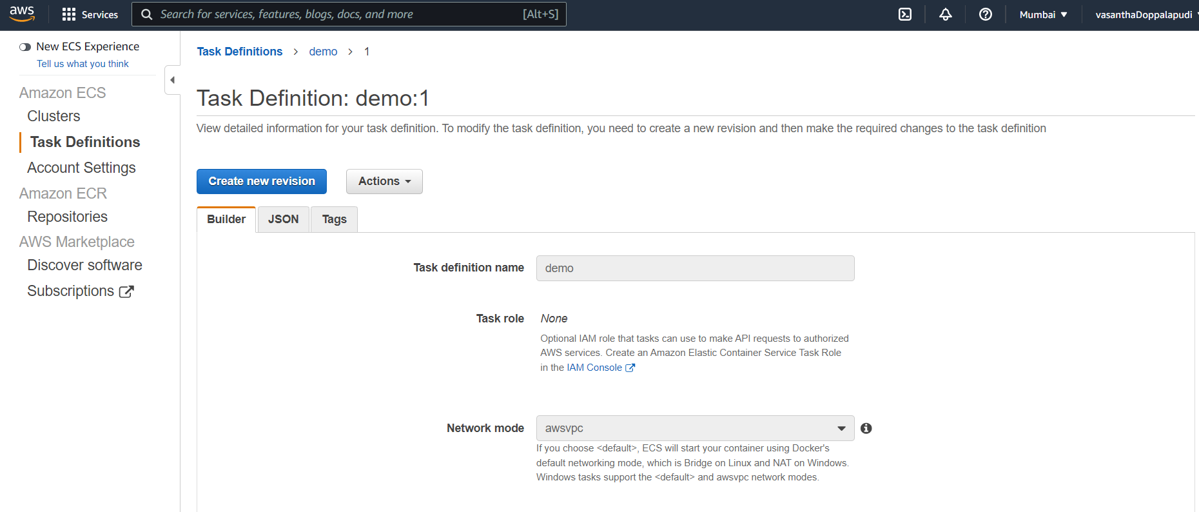
  + Create a cluster
  + 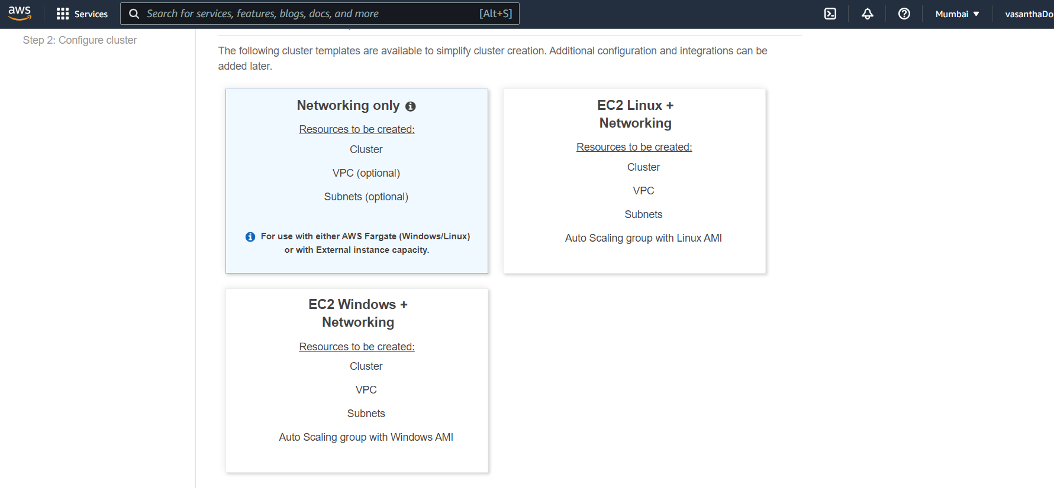
  + 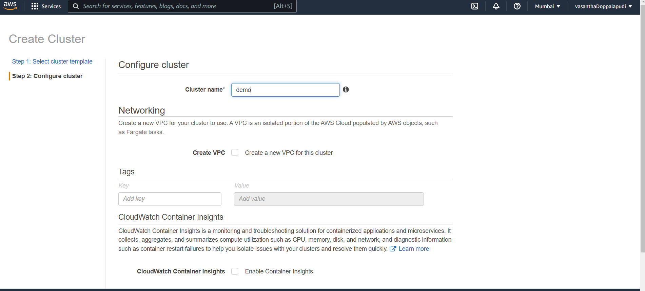
  + Cluster created
  + 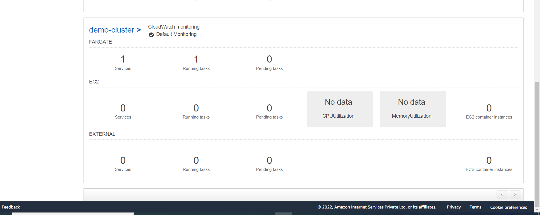
  + Open cluster in that goto services and then click on create
  + 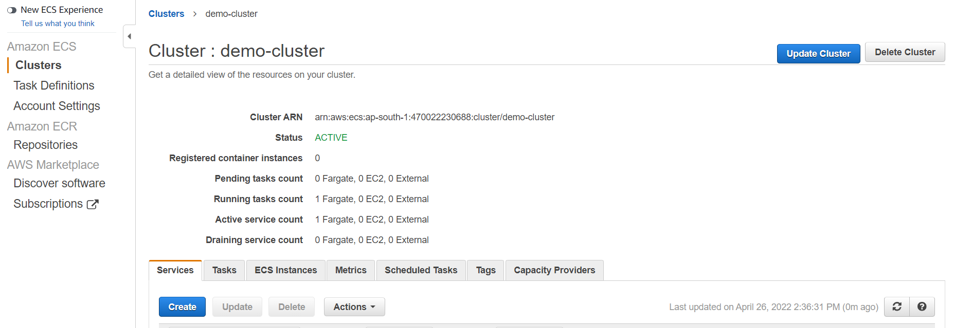
  + 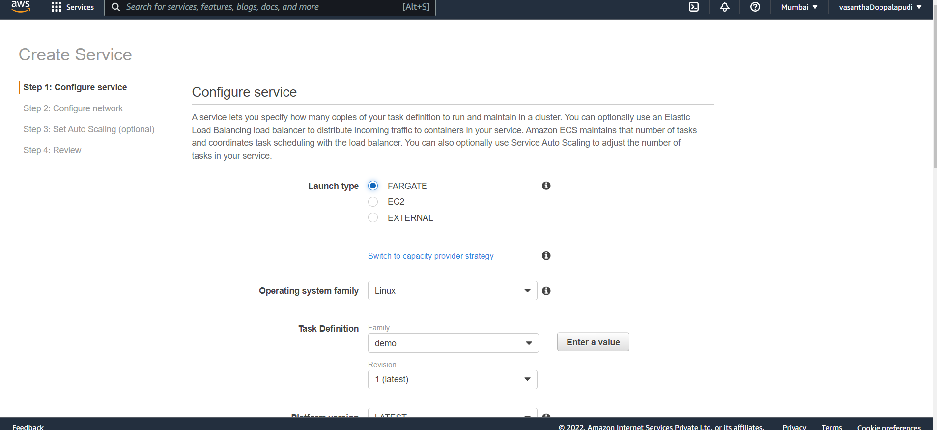
  + Service is created
  + 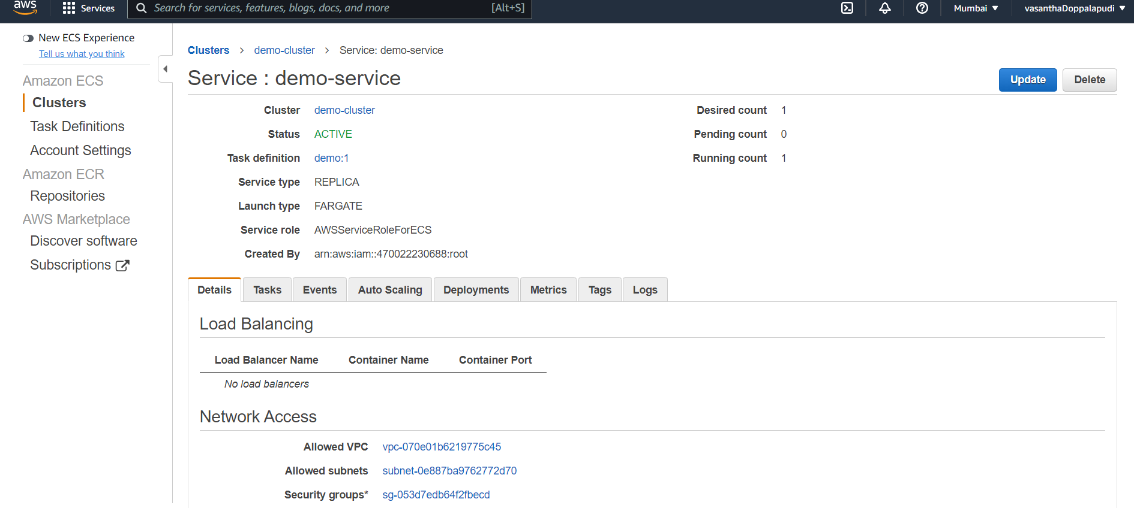
  + Docker image is pulled to ecs
  + 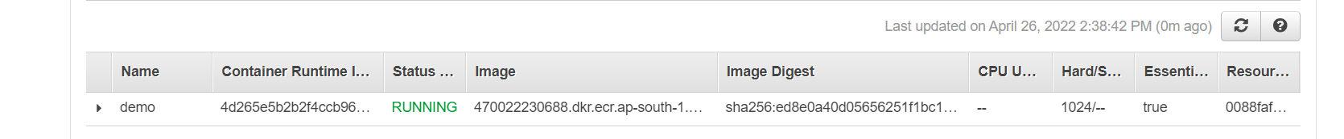
  + For this I have given 8080 port in security group
  + <http://13.233.93.19:8080/>
  + 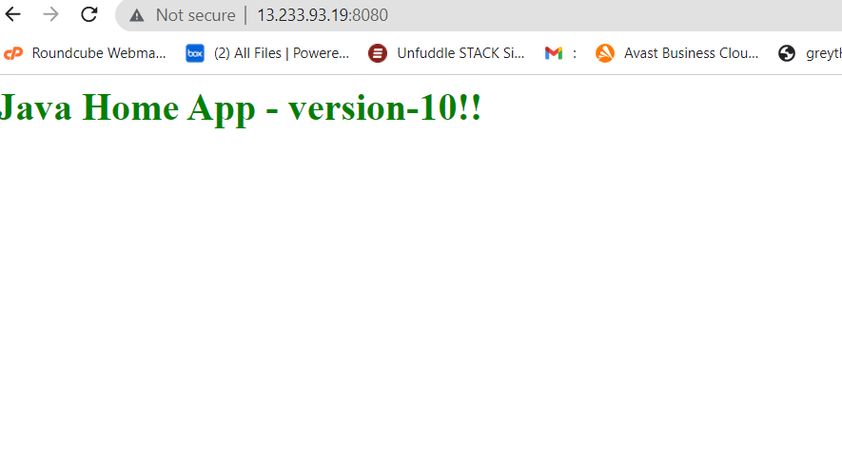
  + The logs are stored in the cloud watch
  + 